**LAB : 3**

**Objective :**

Installation & Configuration of Oracle Virtual box for Window XP & Android

**Requirements :**

1. Windows PC (Windows 7/8/10) / Mac
2. Oracle VM Virtual box
3. Iso images of Windows XP and Android OS
4. Activation key for Windows XP

**Procedure :**

1. **Installing Oracle VM Virtual box**
   1. Visit <https://www.virtualbox.org/> and download VirtualBox software as per your operating system.
   2. Simply run the setup and install it like any normal application.

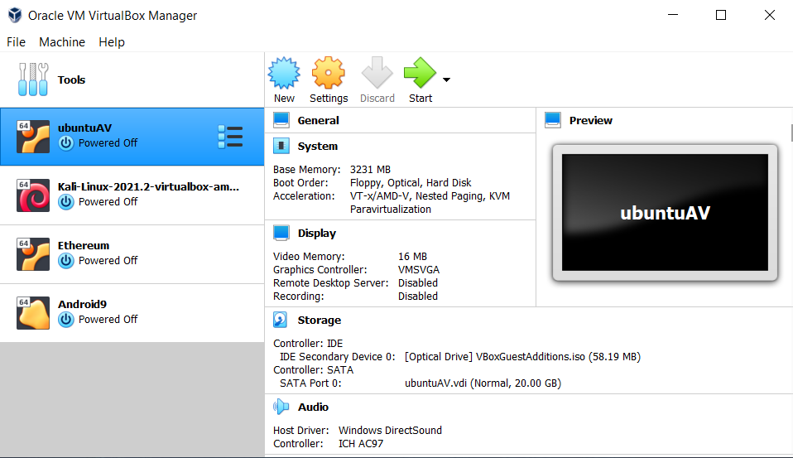

1. **Configure Windows XP on Oracle VM VirtualBox** 
   1. Visit <https://archive.org/details/WinXPProSP3x86> and download iso image of Windows XP operating system. Activation Key is : M6TF9-8XQ2M-YQK9F-7TBB2-XGG88
   2. Open Oracle VM VirtualBox and click on New option.

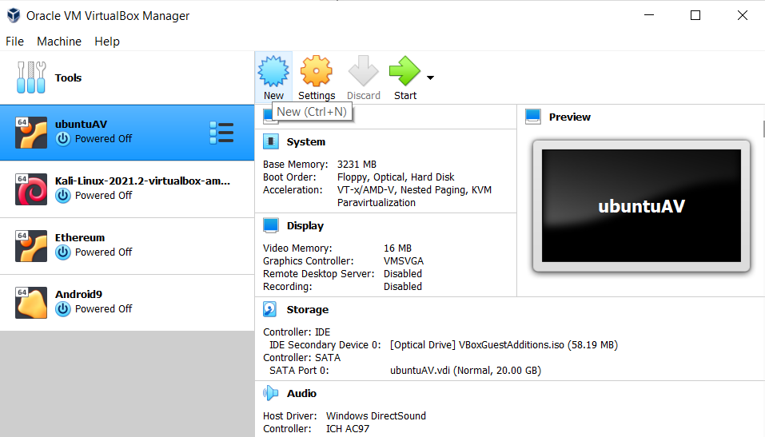

* 1. Enter values as shown in fig

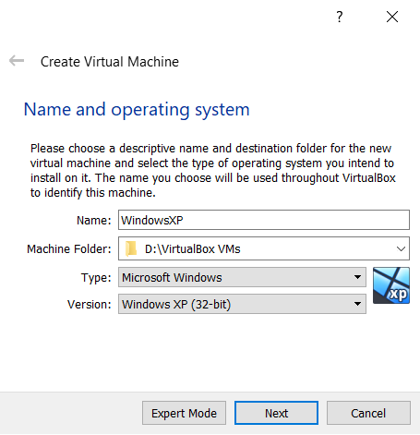

* 1. Set RAM allocated and then create virtual hard disk as shown in fig. below. Here we are using Dynamic allocation for hard disk file.

|  |
| --- |
|  |
|  |
|  |
|  |
|  |

* 1. Select created machine from menu.

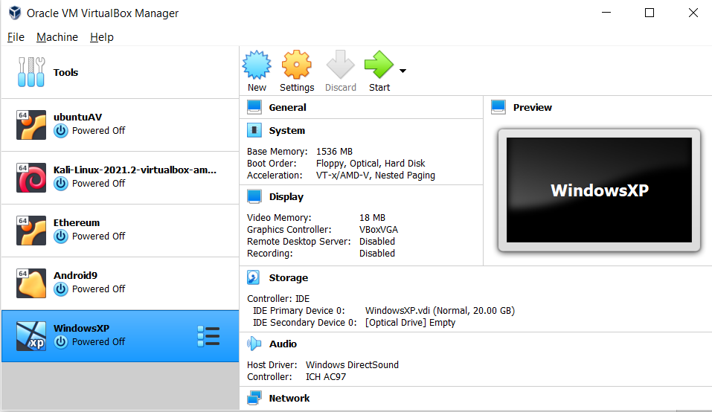

* 1. Select Storage option. Click on Optical Drive and select ‘Choose a disk file’.

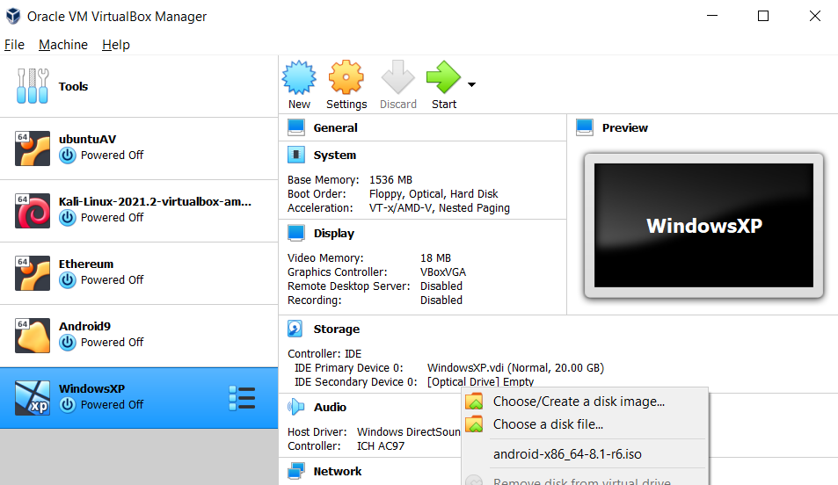

* 1. Select downloaded iso image of OS.

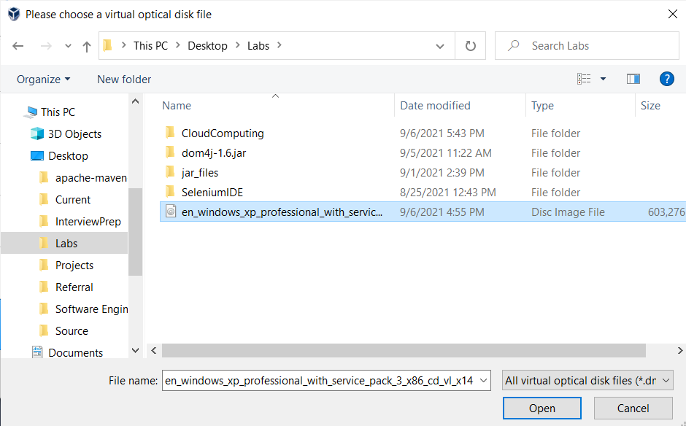

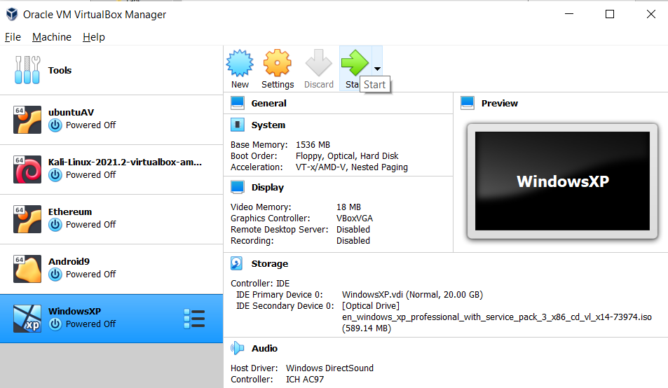

* 1. Click on ‘start’ to boot VM. During first time boot, install setup will be prompted (if iso image is inserted properly as disk).



* 1. In next screens, prompt to install OS and accept license agreement. Select partition space created and format partition using NTFS file system.

|  |
| --- |
|  |
|  |
|  |
|  |
|  |

* 1. In upcoming screens do setup as shown in fig. below.

|  |
| --- |
|  |
|  |
|  |
|  |
|  |
|  |
|  |

* 1. Do initial setup of windows and Windows XP is ready to use on Oracle VM VirtualBox.

|  |
| --- |
|  |
|  |

1. **Configure Android OS on Oracle VM VirtualBox** 
   1. Visit <https://www.android-x86.org/> and download iso image of desired Android OS. Here we are using iso image of Android Pie 9.0.
   2. Open Oracle VM VirtualBox and click on New option.



* 1. Enter values as shown in fig

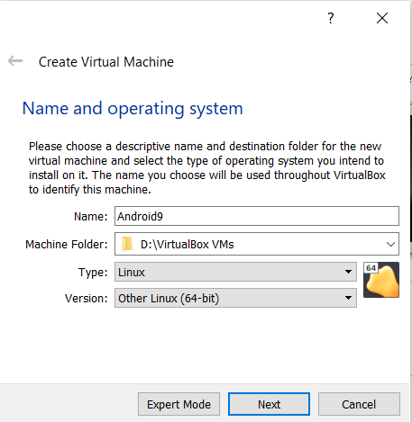

* 1. Set RAM allocated and then create virtual hard disk as shown in fig. below. Here we are using Dynamic allocation for hard disk file.

|  |
| --- |
|  |
|  |
|  |
|  |
|  |

* 1. Select created machine from menu.

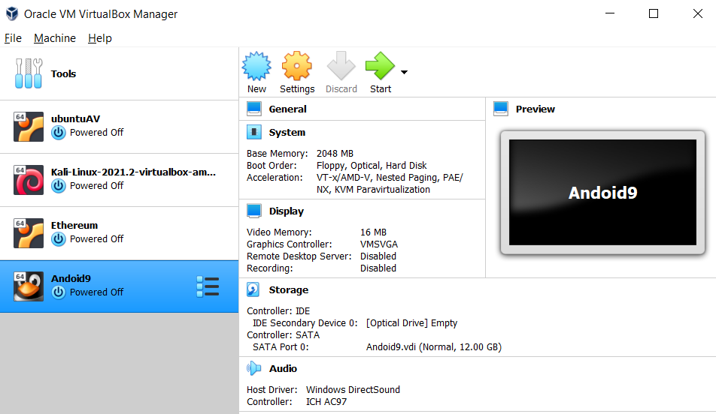

* 1. Select Storage option. Click on Optical Drive and select ‘Choose a disk file’.

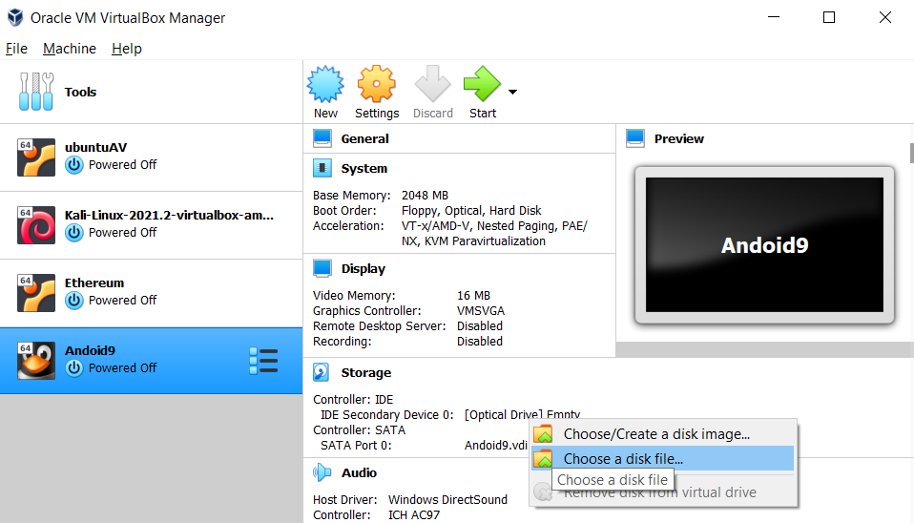

* 1. Select downloaded iso image of OS.

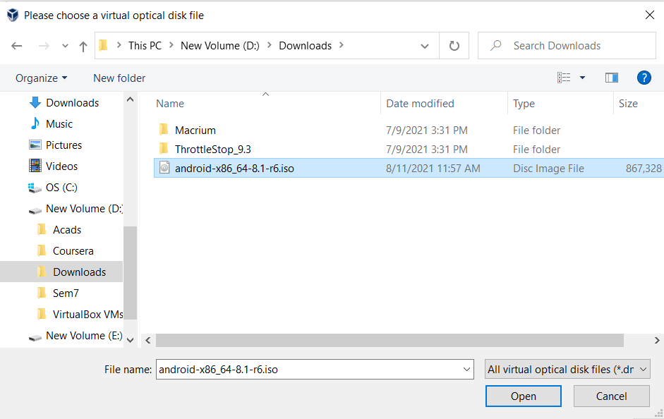

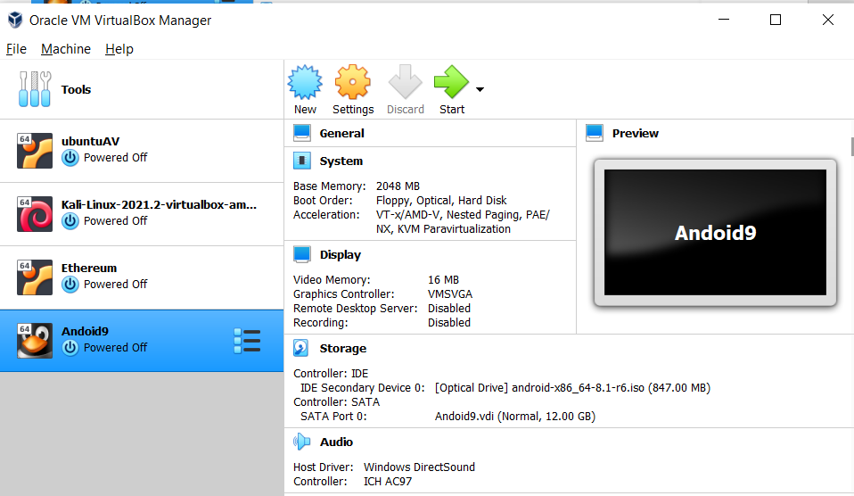

* 1. Following are settings specific to Android based VM.

|  |
| --- |
|  |
|  |

* 1. Click on ‘start’ to boot VM. During first time boot, install setup will be prompted (if iso image is inserted properly as disk).



* 1. In next screens, select Advanced options and then Auto Installation and confirm as shown below. After this Select Run Android-x86.

|  |
| --- |
|  |
|  |
|  |
|  |

* 1. In start up screen, do first time setup on android. Android VM is ready to use.

|  |
| --- |
|  |
|  |